|  |
| --- |
|  |

|  |
| --- |
|  |





Date: 21-February-2020

Location: Fontys, Eindhoven

Tutor: Qin Q. Zhao

Louis Kareem Cocks (Project Leader & Developer) S.N: 3954358

Jose Navarrete Carbonell (Developer) S.N: 3917533

Document version: 4

User Requirements Specifications

By Atomic Peanuts ©

Table of Contents

Agreements with client 2

HR-Functional 3

Requirements 3

HR Use Cases (1-2) 4

HR Use Cases (3-5) 5

HR Use Cases (6-8) 6

HR Use Cases (9-13) 7

HR Use Cases (14-16) 8

GUI (Login & Employee System HR-App) 9

GUI (Employee System HR-App) 10

GUI (Administration System HR-App) 11

GUI (Administration System HR-App) 12

GUI (Administration System HR-App) 13

GUI (Administration System HR-App) 14

GUI (Administration System HR-App) 15

Stock Functional Requirements 16

Stock Use Cases (1-3) 17

Stock Use Cases (4-5) 18

Stock Use Cases (6-7) 19

Stock Use Cases (8-9) 20

Stock Use Cases (10-11) 21

Stock Use Cases (12-13) 22

GUI (Admin-Stock App) 23

GUI (Admin-Stock App) 24

GUI (Admin-Stock App) 25

GUI (Admin-Stock App) 26

GUI (Admin-Stock App) 27

Some of the agreements we have with our client is that we are going to deliver a desktop application by the 27th of March, that will be used by the Human Resource managers and employers of Media Bazaar. The managers will have complete control of the application, where they can add, update, view or delete employees from the system. On the other hand, employees will be able to view and update personal information such as name and address. Both managers and employees will have access to statistics that will give them a better understanding of what is going on, statistics such as how many employees are currently working, how many employees work on a certain day and much more.

In addition to the agreements above, we will be delivering a web application alongside an updated version of the desktop application to our client by 8th of May 2020.

Users of the web application will be stock managers; they will have total control of the application and can view or send requests for a restock when Media Bazaar is low on supply.

By the end of week 18 we will deliver a complete package of 3 applications to our client. The updated desktop application, web application and a separate desktop application that will be used by the department managers; the third application will be to manage the shop per department. So, department managers (if they have the authorization) can pretty much add, update, delete or view products in the shop

# Agreements with client

FR-HR_APP_01: The app should provide a user-friendly interface to let a user easily view statistics and the work schedule.

FR-HR_APP_02: A user should be able to view and update their personal information.

FR-HR_APP_03: A user should be able to add an employee to the system.

FR-HR_APP_04: A user should be able to edit an employee in the system.

FR-HR_APP_05: A user should be able to delete an employee from the system.

FR-HR_APP_06: A user should be able to view an employee in the system.

FR-HR_APP_07: A user should be able to assign an employee to a shift.

FR-HR_APP_08: A user should be able to view all departments.

FR-HR_APP_09: A user should be able to view all employees.

FR-HR_APP_10: A user should be able to login with their email and password.

FR-HR_APP_11: A user should be able to logout from the application.

FR-HR_APP_12: A user should be able to filter the work schedule by roles.

FR-HR_APP_13: A user should be able to search for a staff member.

FR-HR_APP_14: A user should be able view fulltime employees.

FR-HR_APP_15: A user should be able view part-time employees.

FR-HR_APP_16: A user should be able view dayshifts.

FR-HR_APP_17: A user should be able view nightshifts.

# HR-Functional

# Requirements

FR-HR_APP_18: A user should be able to view real-time statistics.

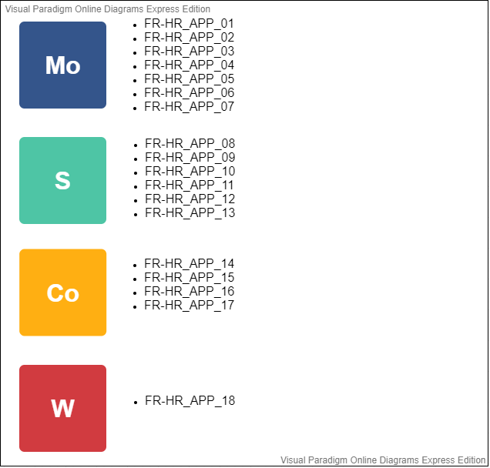

Use case: UC-HR_APP_01: Assigning employees to shifts.

# HR Use Cases (1-2)

Actor: HR Manager.

Pre-conditions: HR Manager is logged in.

Main Success Scenario:

1. A manager double clicks on an employee from the table.
2. Manager gets a message.
3. System opens a new form with employee information.
4. Manager selects time and date to from the dropdown list and calendar.
5. The system confirms that employee is assigned to shift.

Extensions:

2a. Question to assign an employee

1. Manager choose to assign an employee.
2. Continue to MSS step 4.
3. Manager choose to cancel the action.
4. Return to MSS step 1.

4a. Form to assign employee

1. If there’s no data, the system will give an error.
2. If the employee is not available, the system will suggest a reserved employee.
3. If data is available and employee is assigned to a shift, the system will display message. indicating success of the action.
4. End of use case.

Use case: UC-HR_APP_02: Viewing work schedule of staff members.

Actor: HR Manager/Employee.

Pre-conditions: HR Manager/Employee is logged in.

Main Success Scenario:

1. HR Manager/Employee clicks on the view all shifts button.
2. The table displays all members that is assigned to a shift.

Use case: UC-HR_APP_03: Deleting an employee.

Actor: HR Manager.

Pre-conditions: Manager is logged in.

Main Success Scenario:

1. Manager selects an employee from the display.
2. Manager clicks on the fire an employee button.
3. System displays a pop-up window.
4. System displays a message that user is successfully removed from the system.

Extensions:

# HR Use Cases (3-5)

3a. Pop-up window asking the manager to confirm decision

1. Manager clicks yes.
2. Continue to MSS step 4.
3. Manager clicks no.
4. Return to MSS step 2.

Use case: UC-HR_APP_04: Updating an employee’s information.

Actor: HR Manager.

Pre-conditions: Manager is logged in.

Main Success Scenario:

1. Manager selects an employee from the display.
2. Manager clicks on the update an employee button.
3. System opens a new page with employee’s information.
4. Manager fills input with relevant information.
5. Manager clicks on the done button.
6. System displays a successful message.

Use case: UC-HR_APP_05: Adding an employee to the system.

Actor: HR Manager.

Pre-conditions: Manager is logged in.

Main Success Scenario:

1. Manager clicks on the add an employee button.
2. System opens a new page with empty fields.
3. Manger fills input with relevant information.
4. Manager clicks on the ‘done’ button.
5. System displays a successful message.

Use case: UC-HR_APP_06: Filter work schedule information.

Actor: HR Manager/Employee.

Pre-conditions: Manager/Employee is logged in.

Main Success Scenario:

1. User clicks home tab
2. User clicks the filter dropdown list.
3. User selects Manager or Employee from the list.
4. The table will show the information based on selected filter.

Extensions:

1a. User clicks on the Statistics tab

1. Return to MSS step 2

HR Use Cases (6-8)

Use case: UC-HR_APP_07: Search for a staff member.

Actor: HR Manager/Employee.

Pre-conditions: Manager/Employee is logged in.

Main Success Scenario:

1. User clicks home tab.
2. User fills in name of the staff in the textbox.
3. User clicks on the search button.
4. The table will show the information based on the value in the textbox.

Extensions:

1a. User clicks on the Statistics tab

1. Return to MSS step 2.

Use case: UC-HR_APP_08: Sort names in the table.

Actor: HR Manager/Employee.

Pre-conditions: Manager/Employee is logged in.

Main Success Scenario:

1. User clicks home tab.
2. User clicks the sort button.
3. Staff members in the table will be sorted alphabetically by name.

Extensions:

1a. User clicks on the Statistics tab

1. Return to MSS step 2.

Use case: UC-HR_APP_09: Viewing all employees.

Actor: HR Manager.

Pre-conditions: Manager is logged in.

Main Success Scenario:

1. Manager clicks Statistics tab.
2. Manager clicks the view all employees button.
3. System will load all employees in the table.

Use case: UC-HR_APP_10: Viewing all departments.

Actor: HR Manager.

Pre-conditions: Manager is logged in.

Main Success Scenario:

1. Manager clicks Statistics tab.
2. Manager clicks the view all department button.
3. System will load all departments in the table.

Use case: UC-HR_APP_11: Viewing employee personal information.

Actor: HR Manager.

Pre-conditions: Manager is logged in.

HR Use Cases (9-13)

Main Success Scenario:

1. Manager clicks Employee management tab.
2. Manager selects an employee from the employee’s table.
3. Manager clicks the View details button.
4. System displays a new form with employee’s information.

Use case: UC-HR_APP_13: View Part-time shifts.

Actor: HR Manager.

Pre-conditions: Manager is logged in.

Main Success Scenario:

1. Employee clicks on History tab.
2. Employee clicks view part-time button.
3. System will display all part-time workers in the table.

Use case: UC-HR_APP_14: View Full-time shifts.

Actor: HR Manager.

Pre-conditions: Manager is logged in.

Main Success Scenario:

1. Employee clicks on History tab.
2. Employee clicks view full-time button.
3. System will display all full-time workers in the table.

Use case: UC-HR_APP_15: View Dayshifts.

Actor: Employee.

Pre-conditions: Employee is logged in.

Main Success Scenario:

1. Employee clicks on History tab.
2. Employee clicks view dayshifts button.
3. System will display all dayshifts in the table.

HR Use Cases (14-16)

Use case: UC-HR_APP_16: View Nightshifts.

Actor: Employee.

Pre-conditions: Employee is logged in.

Main Success Scenario:

1. Employee clicks on History tab.
2. Employee clicks view nightshifts button.
3. System will display all nightshifts in the table.

GUI (Login & Employee System HR-App)

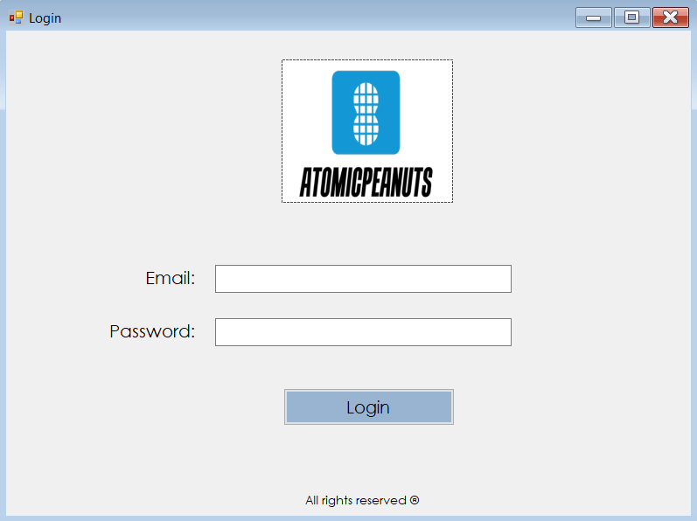

* Login page. User logs into the application with his/her credentials.

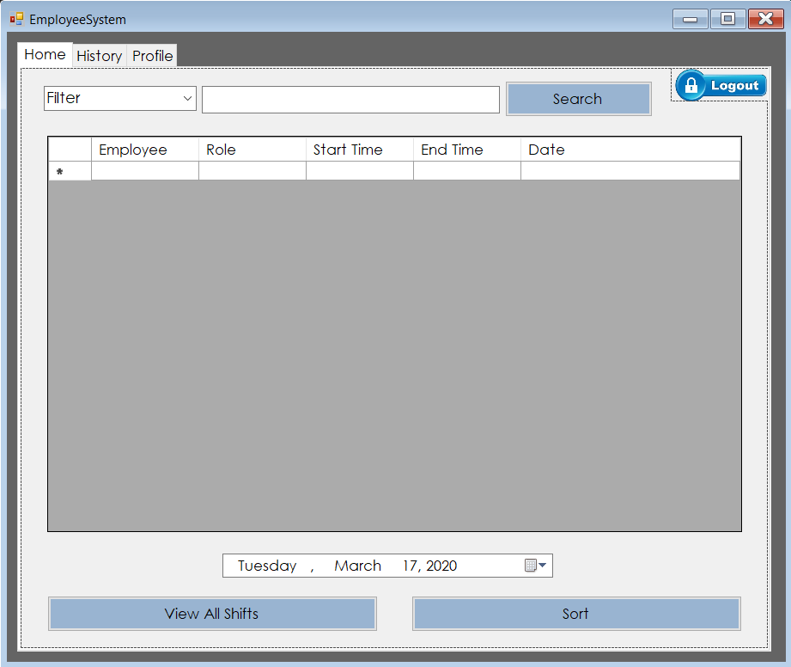

* After logging in, employees will get a schedule overview where they can view all work shifts.

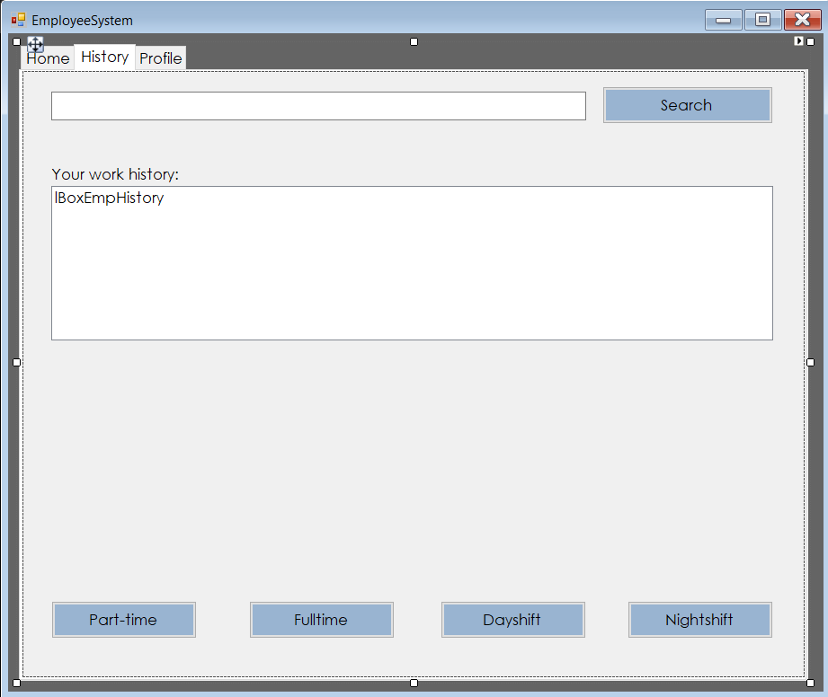

* Employees will only be able to view their work history and different shifts within the department they are employed.

GUI (Employee System HR-App)

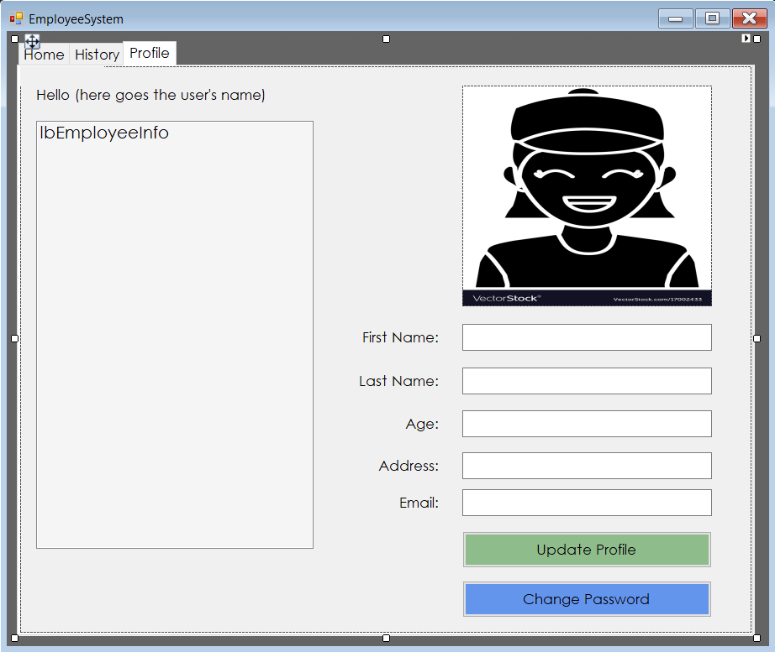

* The employee can view their profile or choose to update personal information by filling in the textboxes and clicking update profile.

GUI (Administration System HR-App)

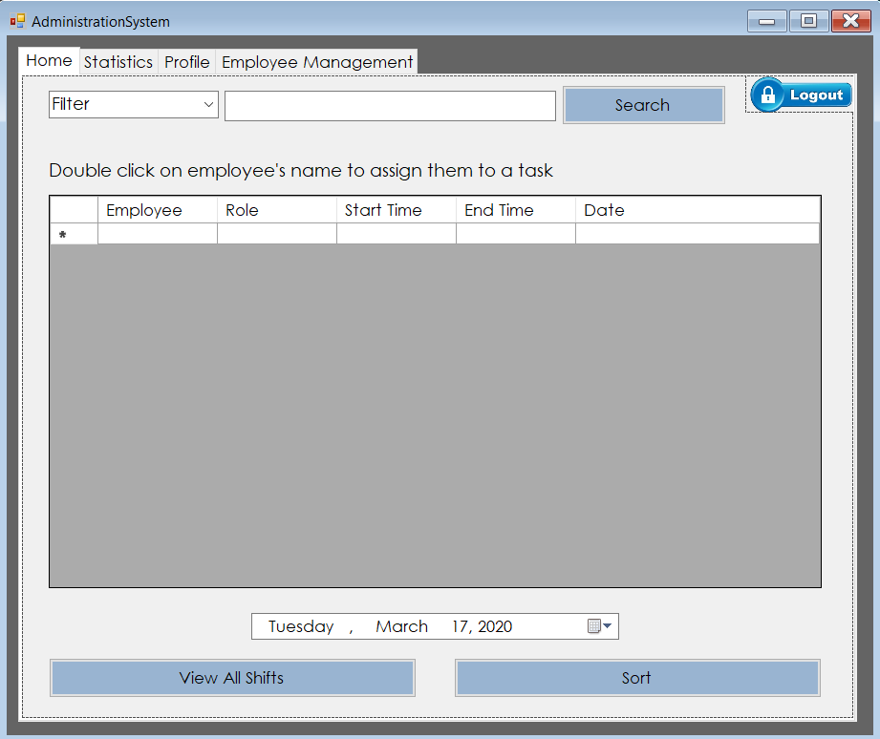

* After the manager logs in, they will get an overview of the schedule.   
  As manager, they would be able to view all work shifts, sort table or assign an employee to a shift.

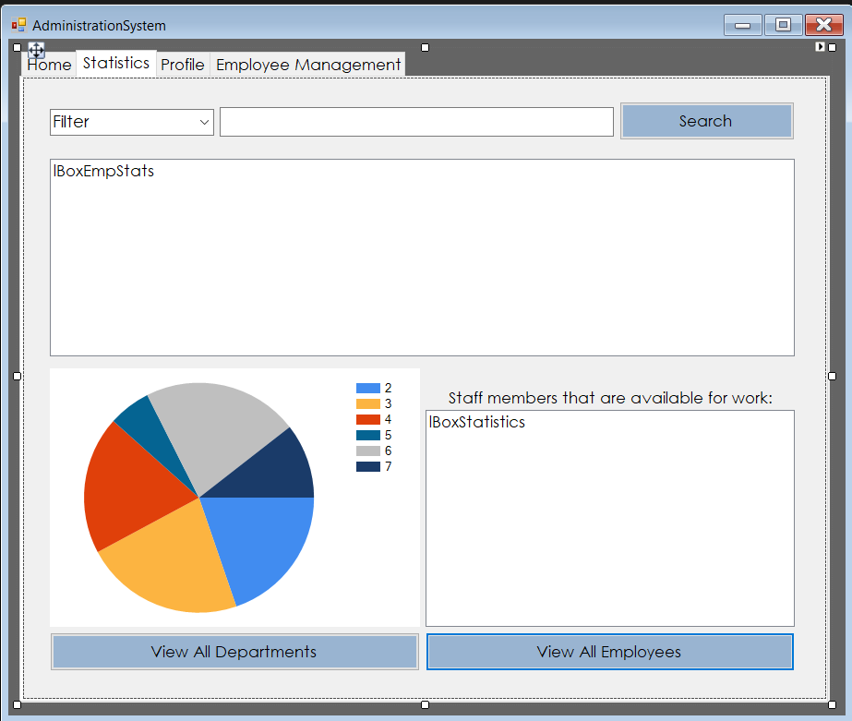

* Managers will be able to view all departments, all employees and get a statistical overview of all data.

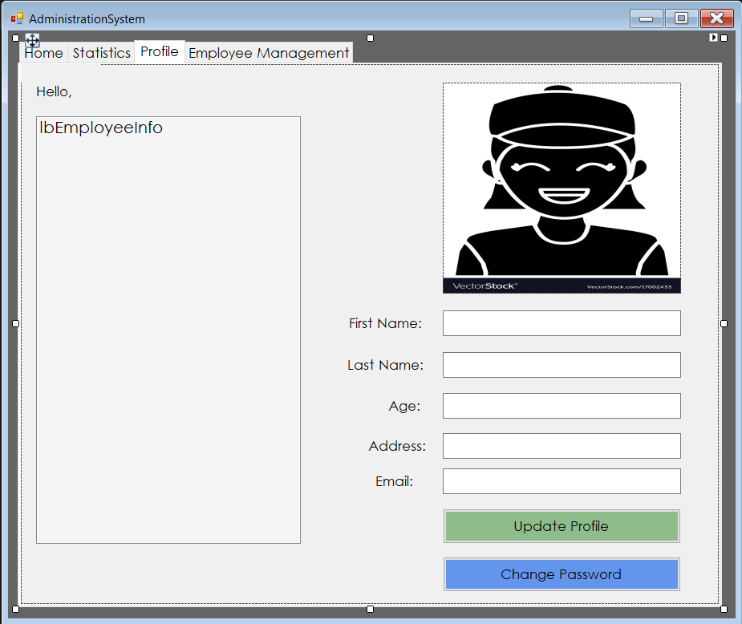

* Managers will be able to view and update their profile on the Profile tab.

GUI (Administration System HR-App)

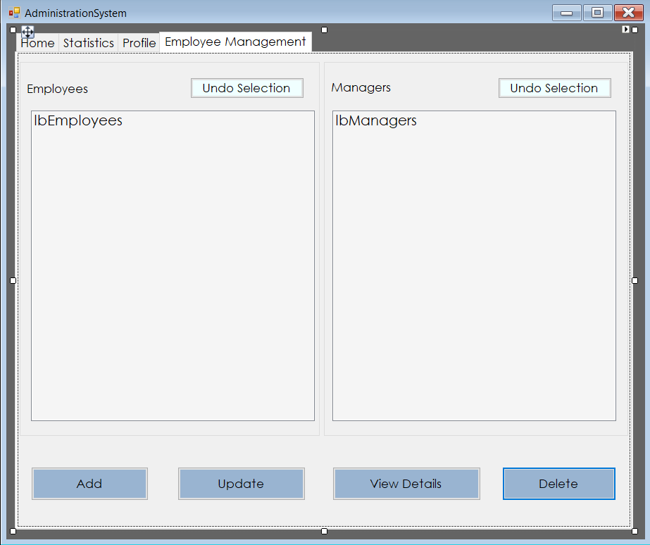

* On this page, managers can add, view, update or delete employees from the system.

GUI (Administration System HR-App)

# 

* When a manager chooses to assign an employee, this form will be displayed.

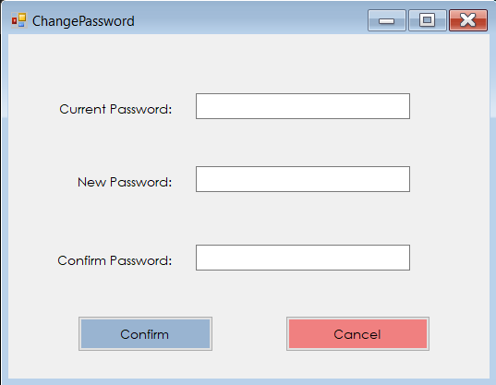

* This form will be displayed when manager wants to change a staff member’s password.

GUI (Administration System HR-App)

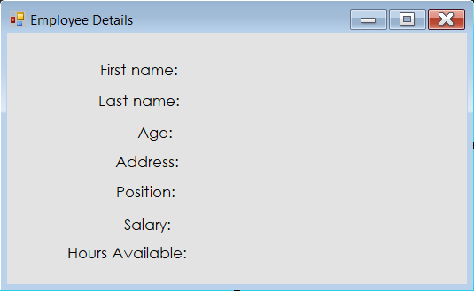

* Managers will be able to view personal information of employees; this can be done when clicking view details button on the employee management tab.

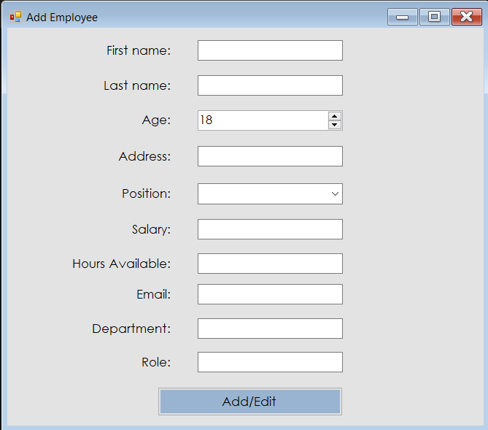

* When managers decide to add an employee, this form will be displayed. Behind the scenes a schedule will be automatically created as well.

GUI (Administration System HR-App)

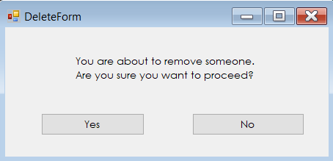

* When deleting an employee or firing an employee, this form will be displayed to make sure that the manager does not fire an employee by mistake.

Stock Functional Requirements

FR-SM_APP_01: A u**ser must be able to view products per category.**

FR-SM_APP_02: **A user must be able to see all products.**

FR-SM_APP_03: **A user must be able to see all orders.**

FR-SM_APP_04: **A user must be able to make an order requests for stock.**

FR-SM_APP_05: **A user should be able to view a product on product info page.**

FR-SM_APP_06: **A user must be able to add categories.**

FR-SM_APP_07: **A user should be able to receive an email after requesting an order for new stock.**

FR-SM_APP_08: **A user should be able to search inventory on the inventory page.**

FR-SM_APP_09: **A user should be able to search categories on the category page.**

FR-SM_APP_10: **A user should be able to search orders on the orders page.**

FR-SM_APP_11: **A user must be able to login.**

FR-SM_APP_12: **A user must be able to logout.**

****FR-SM_APP_13**: A user must be able to update a category.**

Stock Use Cases (1-3)

Use case: UC-STOCK_APP_01: View all products within a category.

Actor: Stock Manager.

Pre-conditions: Manager is logged in.

Main Success Scenario:

1. Manager clicks on Categories from the side-menu.
2. Manager clicks on the category name (link).
3. System will open a page with products.

Extensions:

3a. System will display data

1. If data is available, the table will be filled with products.
2. If no data is available, a warning message will display that no products are available.
3. End of step 3.

Use case: UC-STOCK_APP_02: View all products.

Actor: Stock Manager.

Pre-conditions: Manager is logged in.

Main Success Scenario:

1. Manager clicks on Inventory from the side-menu.
2. System will display a page with all products and additional information.

Use case: UC-STOCK_APP_03: View all orders.

Actor: Stock Manager.

Pre-conditions: Manager is logged in.

Main Success Scenario:

1. Manager clicks on Orders from the side-menu.
2. System will display a page with all orders in a table.

Stock Use Cases (4-5)

Use case: UC-STOCK_APP_04: **Making an order request for new stock**.

Actor: Stock Manager.

Pre-conditions: Manager is logged in.

Main Success Scenario:

1. Manager clicks on Stock Request from the side-menu.
2. System opens a page with inputs and dropdown lists.
3. Manager fills in and selects information then submits the requests.
4. The system will display a pop-up message that requests is successful with order ID.

Extensions:

3a. Submitting the request

1. If email is correct and inputs is filled, the request will be submitted.
2. If email is incorrect and inputs are not filled, the request will fail, and error message will notify user that request is failed.
3. End of step 3.

Use case: UC-STOCK_APP_05: **Viewing product information.**

Actor: Stock Manager.

Pre-conditions: Manager is logged in.

Main Success Scenario:

1. Manager clicks on Inventory from the side-menu.
2. System will display a page with all products and additional information.
3. Manager clicks on the product name (link).
4. System will open a page with product information displayed in a table.

Stock Use Cases (6-7)

Use case: UC-STOCK_APP_06: **Add a new category**.

Actor: Stock Manager.

Pre-conditions: Manager is logged in.

Main Success Scenario:

1. Manager clicks on Categories from the side-menu.
2. System opens a page with categories information in a table.
3. Manager clicks the “Add category” button.
4. The system opens a page with empty inputs.
5. Manager fills inputs and submits.

Extensions:

5a. Submitting a new category:

1. If inputs are filled, the request will be submitted.
2. If inputs are empty, the request will fail, and error message will notify user that request is failed.
3. End of step 3.

Use case: UC-STOCK_APP_07: **Receive email after requesting new stock.**

Actor: Stock Manager.

Pre-conditions: Manager is logged in.

Main Success Scenario:

1. Manager clicks on Stock Request from the side-menu.
2. System opens a page with inputs and dropdown lists.
3. Manager fills in and selects information then submits the requests.
4. Managers receives an email with order is confirmed and order ID.

Stock Use Cases (8-9)

Use case: UC-STOCK_APP_08: **Searching information on inventory page**.

Actor: Stock Manager.

Pre-conditions: Manager is logged in.

Main Success Scenario:

1. Manager clicks on Inventory from the side-menu.
2. System will display a page with all products and additional information.
3. Manager types word or letter in the search bar

Extensions:

3a. Searching:

1. If data exists, the table will display information in table.
2. If data does not exist, the table will be empty, thus, no data found.
3. End of step 3.

Use case: UC-STOCK_APP_09: **Searching information on categories page**.

Actor: Stock Manager.

Pre-conditions: Manager is logged in.

Main Success Scenario:

1. Manager clicks on Categories from the side-menu.
2. System will display a page with all categories.
3. Manager types word or letter in the search bar

Extensions:

3a. Searching:

1. If data exists, the table will display information in table.
2. If data does not exist, the table will be empty, thus, no data found.
3. End of step 3.

Stock Use Cases (10-11)

Use case: UC-STOCK_APP_10: **Searching information on orders page**.

Actor: Stock Manager.

Pre-conditions: Manager is logged in.

Main Success Scenario:

1. Manager clicks on Orders from the side-menu.
2. System will display a page with all orders.
3. Manager types word or letter in the search bar

Extensions:

3a. Searching:

1. If data exists, the table will display information in table.
2. If data does not exist, the table will be empty, thus, no data found.
3. End of step 3.

Use case: UC-STOCK_APP_11: **Logging in**.

Actor: Stock Manager.

Main Success Scenario:

1. Manager goes to site URL.
2. System will display a page with an empty form.
3. Manager types passcode.
4. Managers logs in.

Extensions:

3a. Attempting to log in:

1. If passcode is correct, the manager will be logged in and redirected to homepage.
2. If passcode is incorrect the page will be refreshed, thus the passcode is not valid.
3. If the passcode is not equal to a 4-digit number, the system will display an error. Please enter the correct passcode
4. End of step 3.

Stock Use Cases (12-13)

Use case: UC-STOCK_APP_12: **Logging out**.

Actor: Stock Manager.

Pre-conditions: Manager is logged in.

Main Success Scenario:

1. Manager clicks on Logout from the side-menu.
2. System will log manager out and redirect to the login page.

Use case: UC-STOCK_APP_13: **Update a category**.

Actor: Stock Manager.

Pre-conditions: Manager is logged in.

Main Success Scenario:

1. Manager clicks on Categories from the side-menu.
2. System opens a page with categories information in a table.
3. Manager clicks “Edit” button from the table.
4. The system opens a page with pre-filled inputs (The selected category data).
5. Manager fills new information in and submits.

Extensions:

5a. Submitting the updated category:

1. If inputs are filled, the request will be submitted.
2. If inputs are empty, the request will fail, and error message will notify user that request is failed.
3. End of step 3.

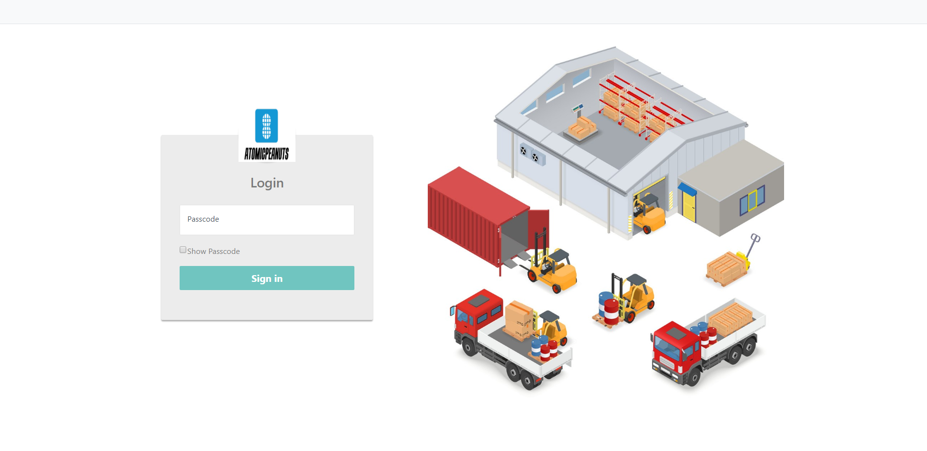

This is the login page, where user will enter their passcode to log in. Later implementation will be that user receives an email with another code (two-step verification).

GUI (Admin-Stock App)

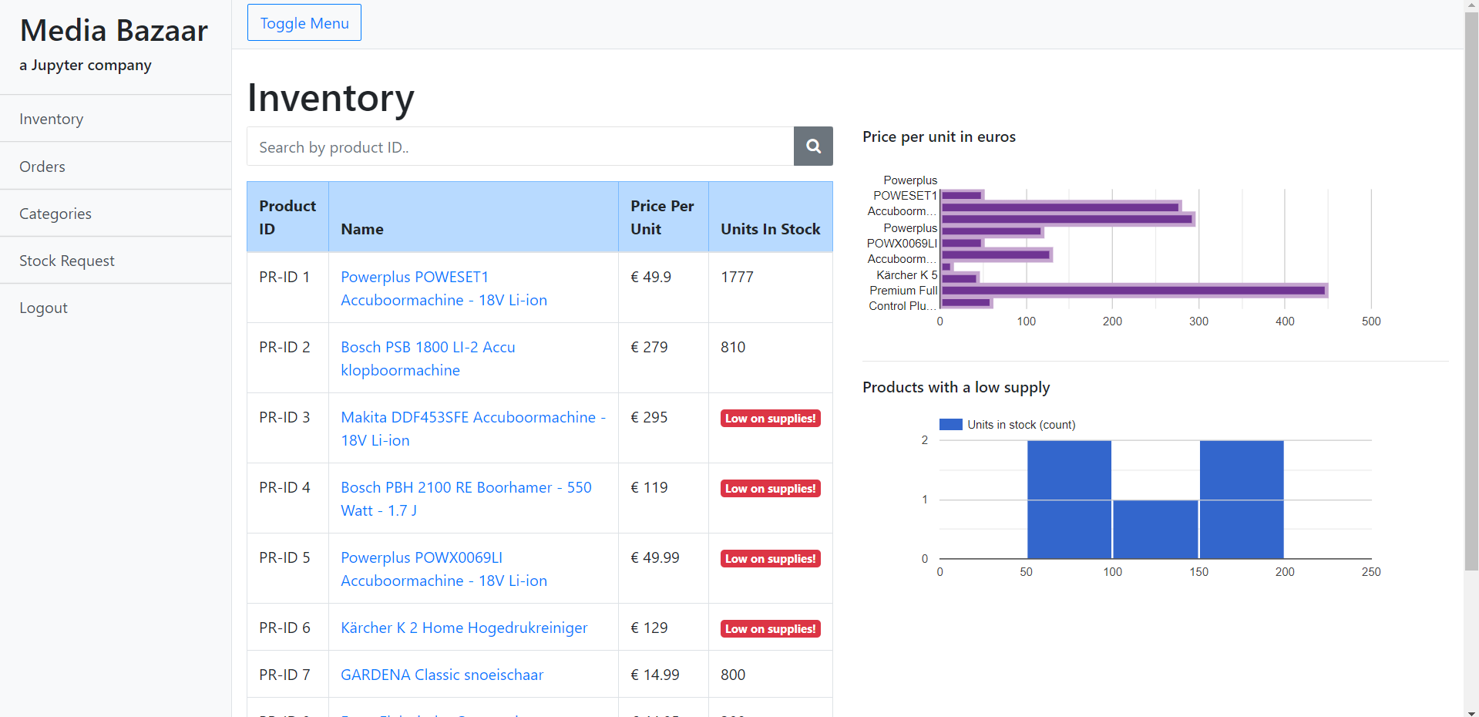

This is the homepage with information about products and the number of units in stock per product.

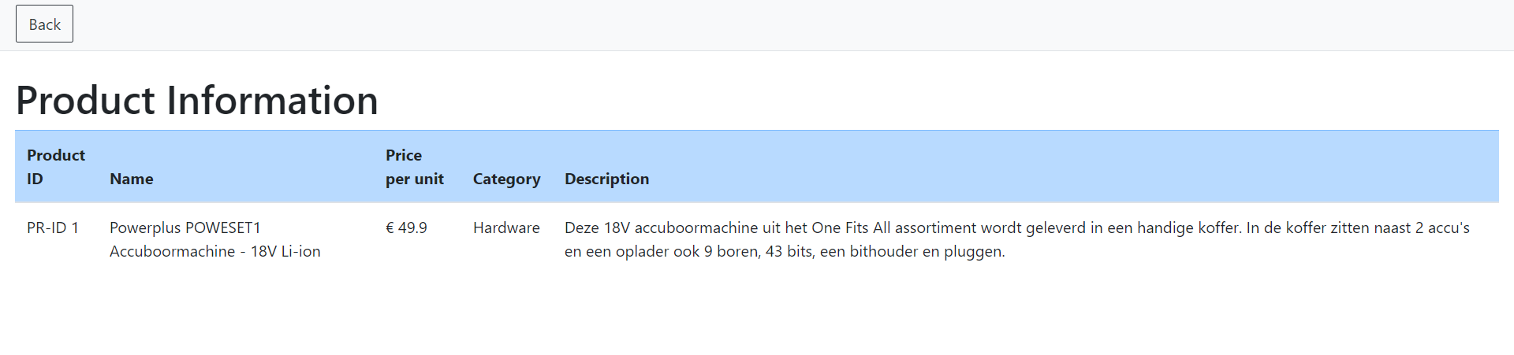

This page displays detailed information about a product with a back button.

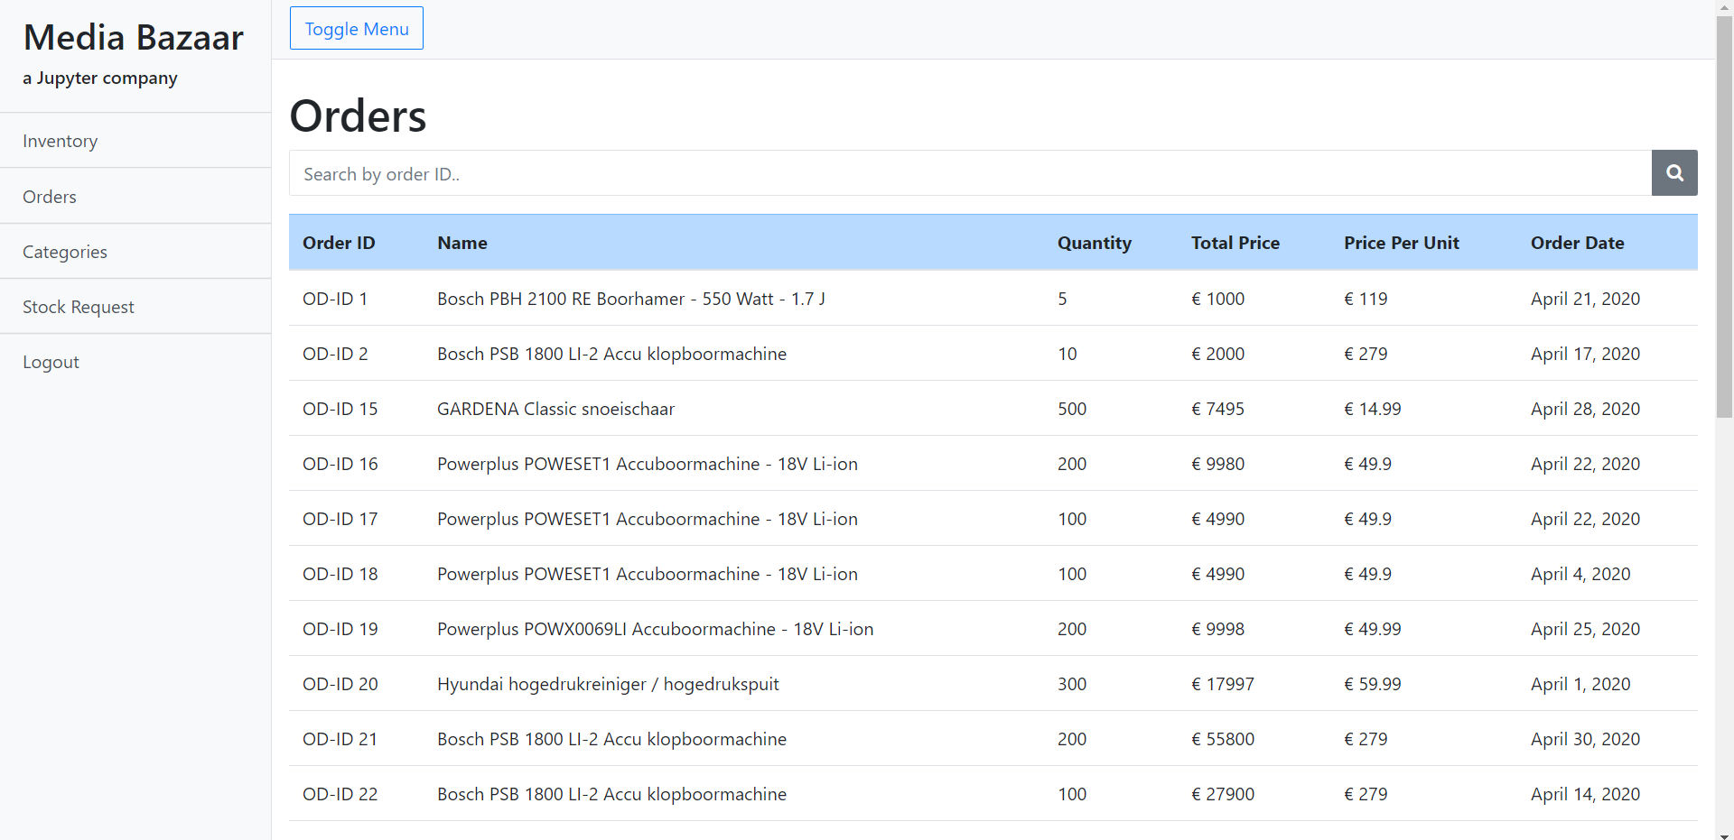

This page displays information about all order, it’s a order history page where user can search for order by date, id, name or price.

GUI (Admin-Stock App)

GUI (Admin-Stock App)

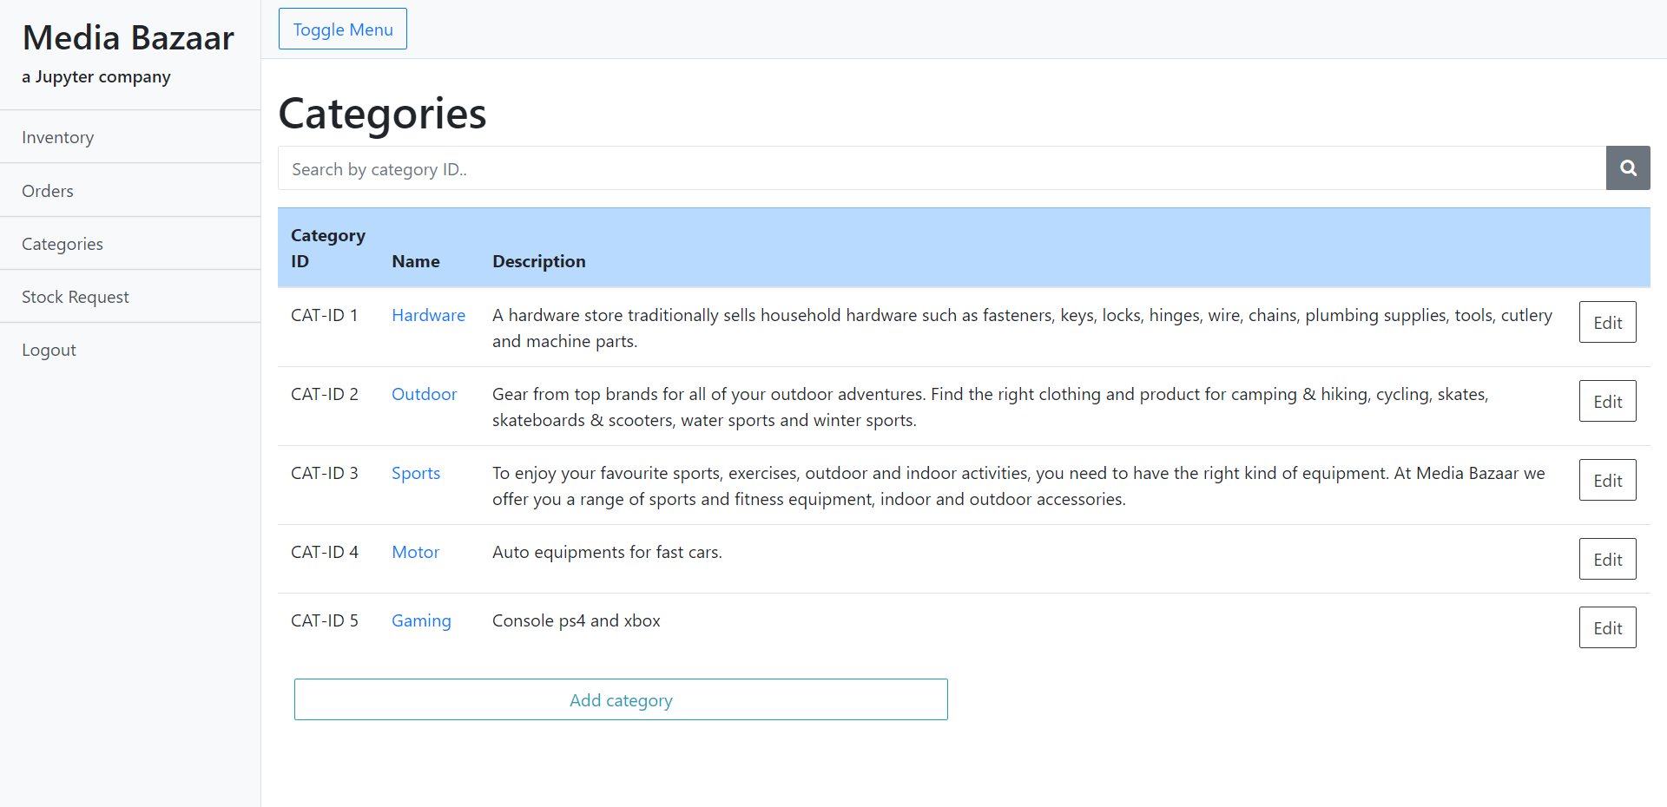

This is the categories page; this page displays information about all categories in a table with an edit button and a add category button. Also, user can click on a category name to open a page with all products within that category

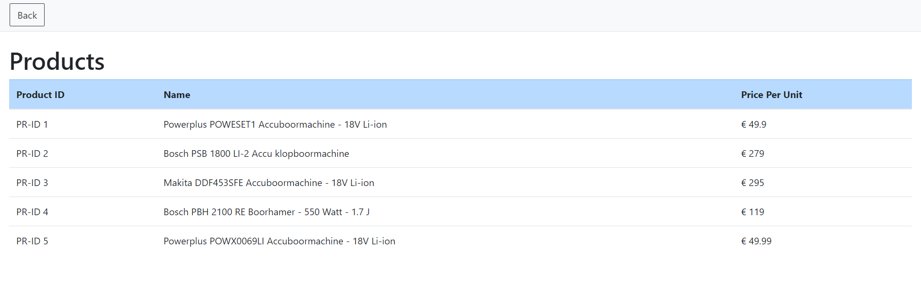

After clicking category name, the system will open this page. This page displays all the products within a category and back button.

GUI (Admin-Stock App)

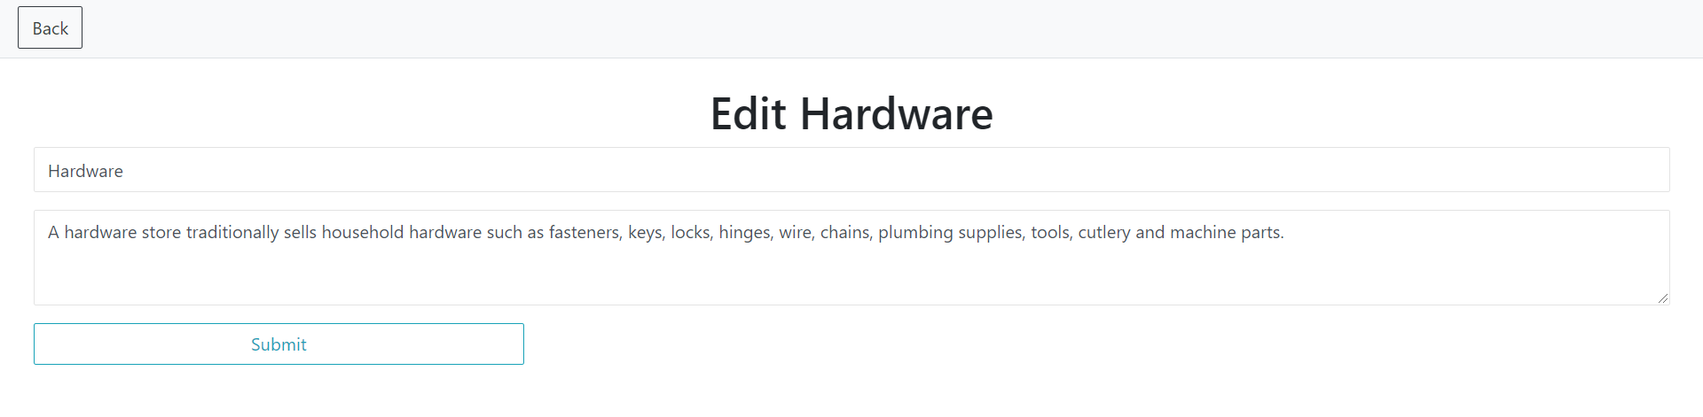

After manager clicks the edit button on the table. This page will open with pre-filled information about the category.

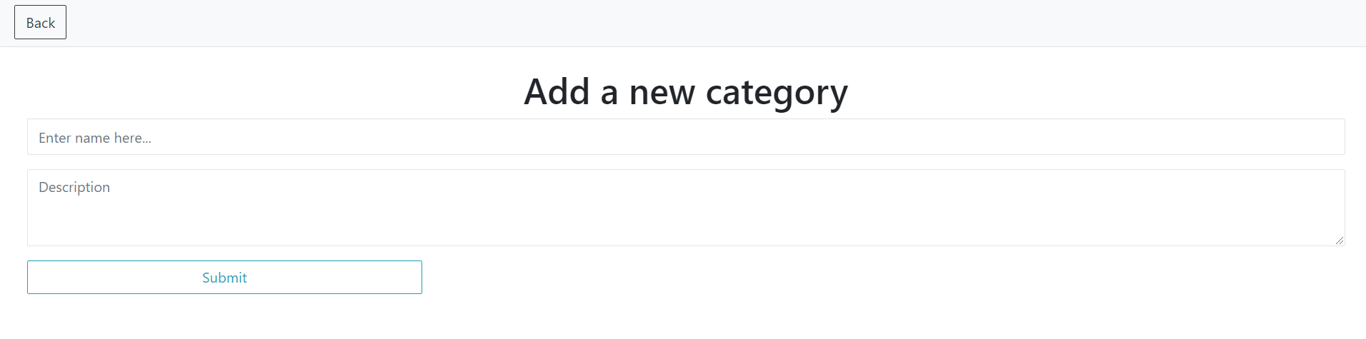

After clicking the add category button. This page will open with empty inputs.

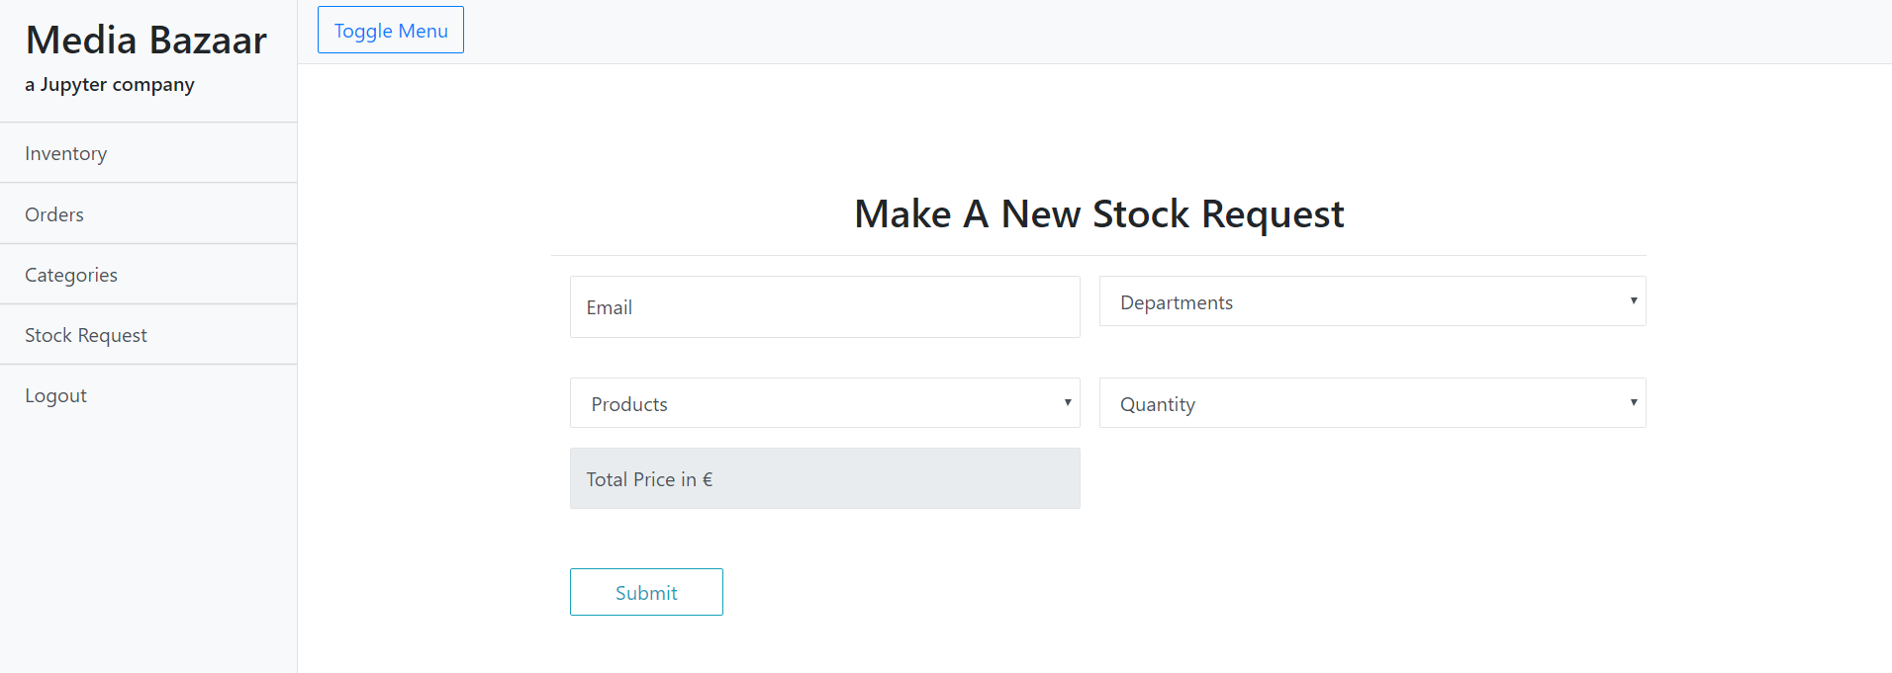

This is the page where manager can make a stock request.

GUI (Admin-Stock App)

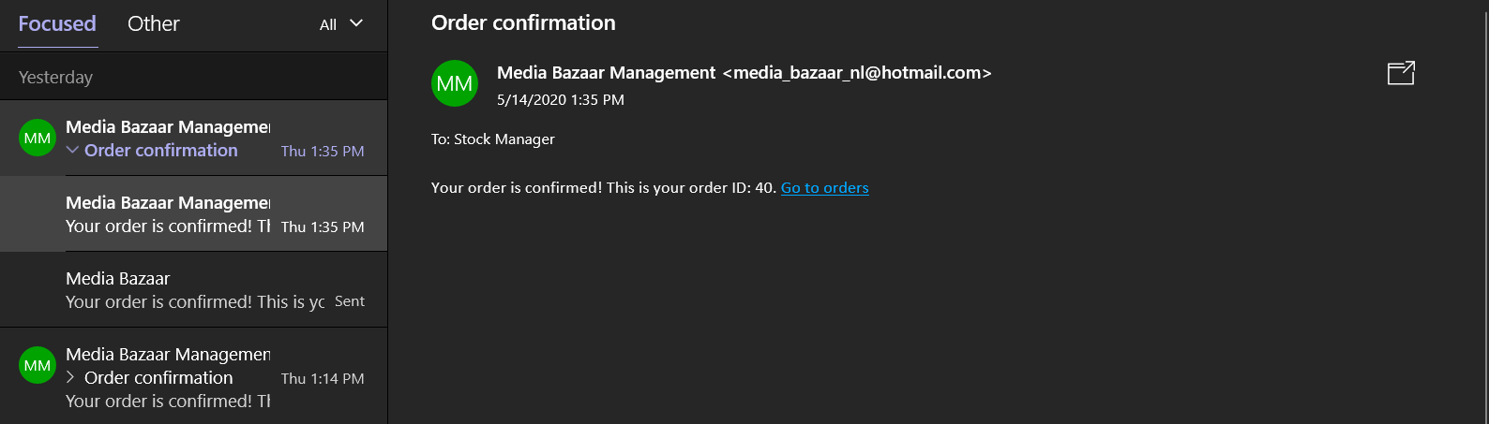

After making a request and if confirmed, the user will receive this email with the order ID.